Name: Ashwin Satone
Roll No.: 1181

2.1Create user tom , bob , sam , prince :-
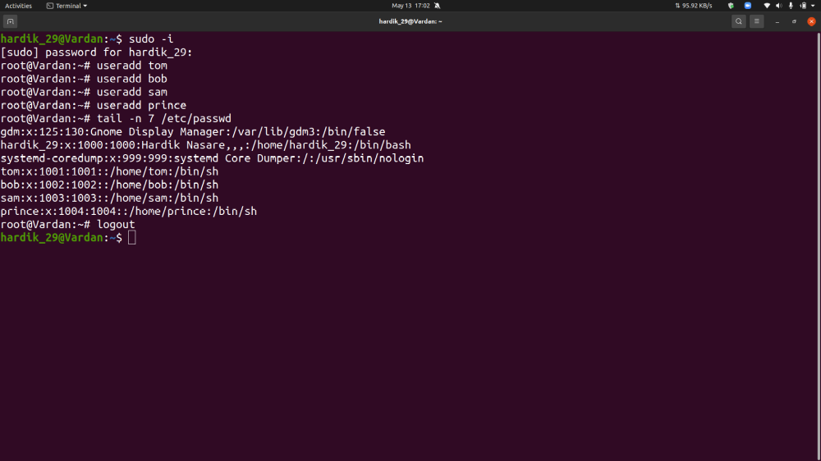
2. Create Group dac , dbda ,ditiss :-
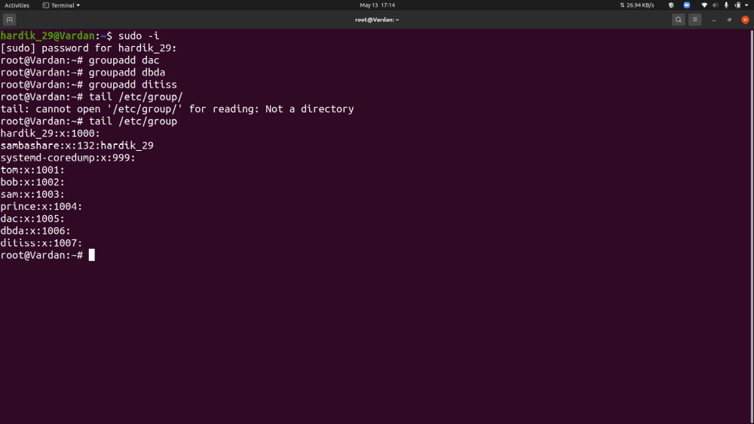

3. add user Tom in dac Bob in dbda Sam in ditiss :-
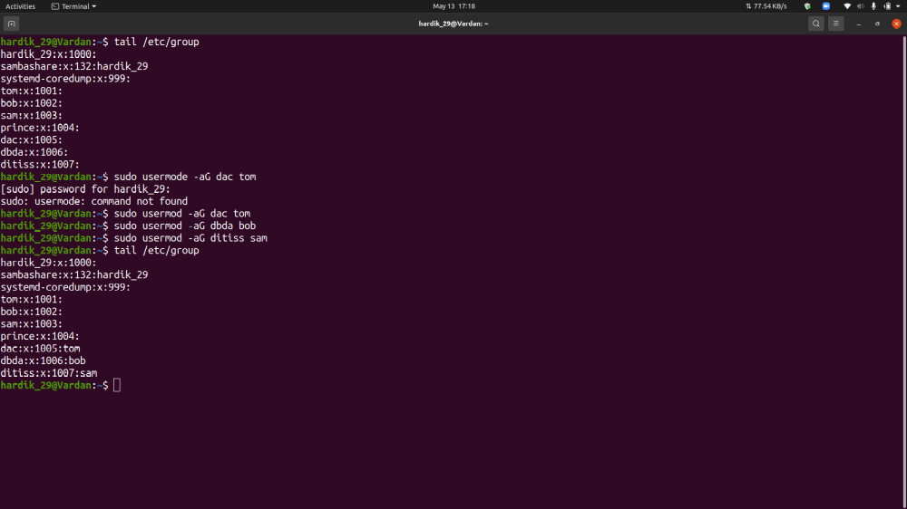

4. login as prince and create iacsd directory in /tmp and create 4 files in iacsd with name project-1 project-2 upto 4 :-
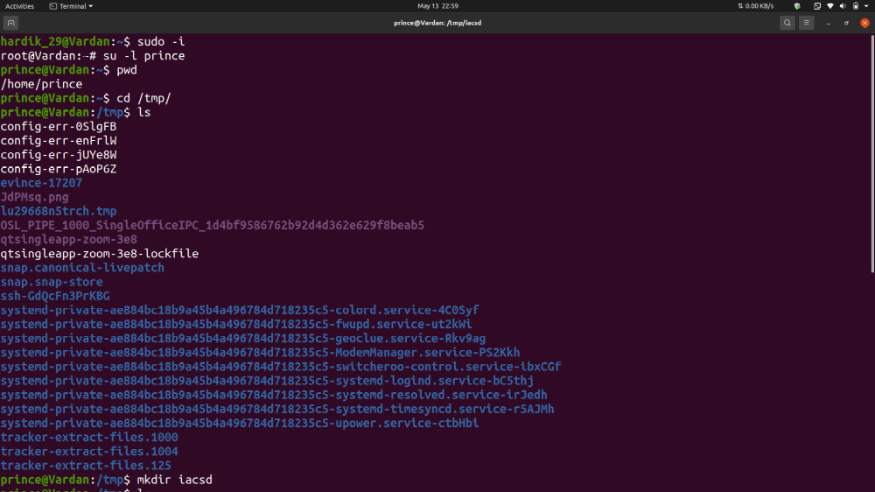
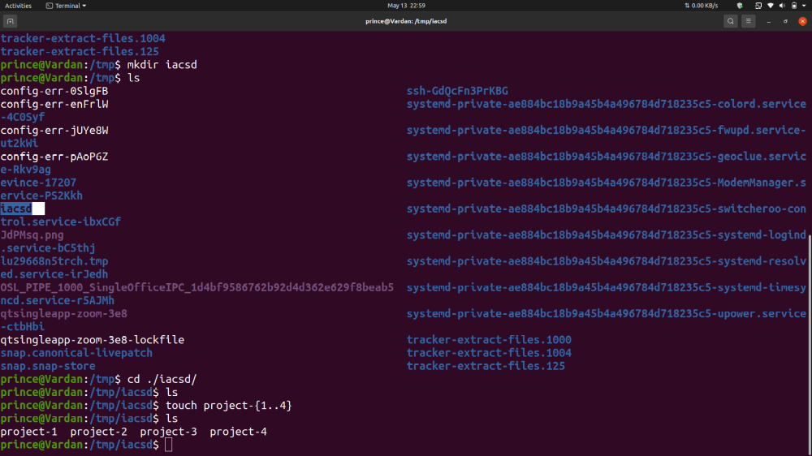

5. assign permissions to project files as below

Project-1 – tom should be owner of this
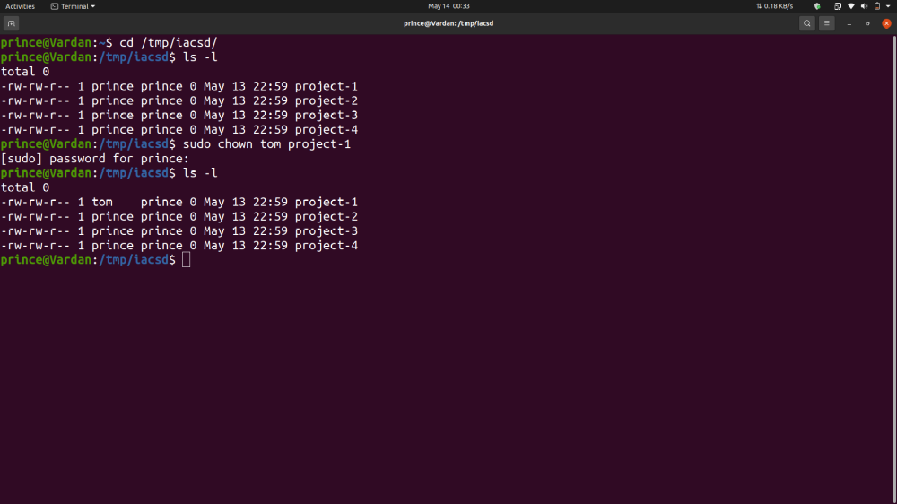

Project-2 – dac should be owner of this
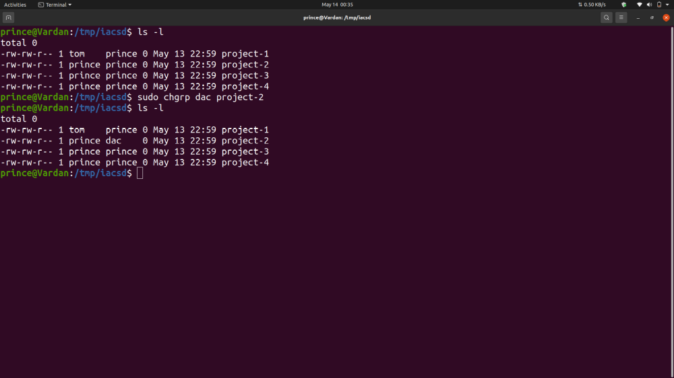

Project-3 --- others should not have any permission but tom should have rw access
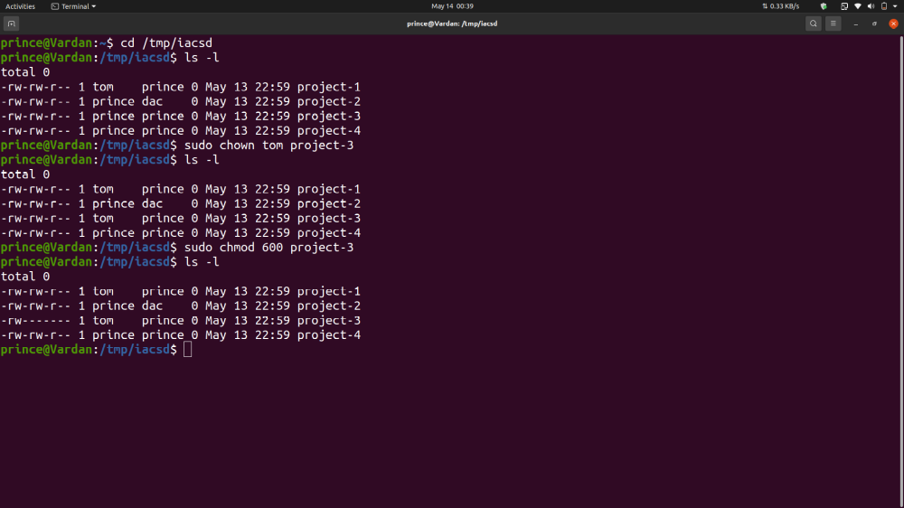

Project-4 – dbda group should have rwx permissions. :-
